Double click the HP Solution Center icon on the Desktop |  | 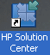
Click either the Scan Picture, or Scan Document button, as appropriate. |  | 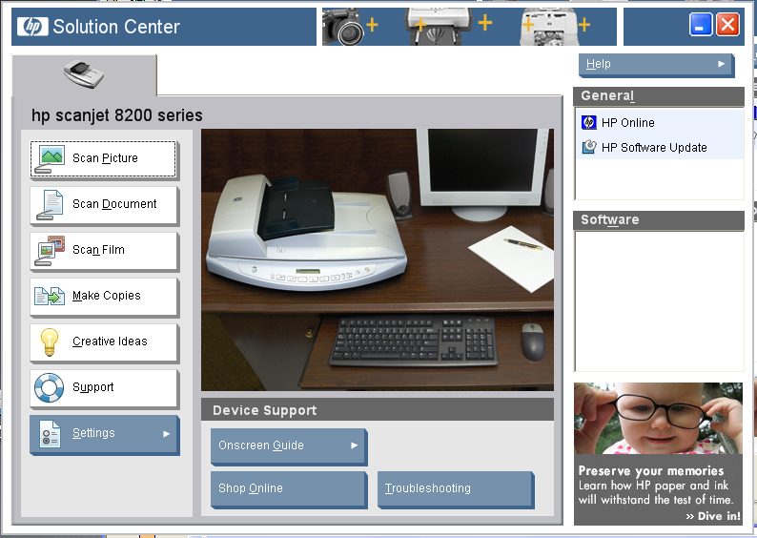
Scanning a Picture
Place the picture to be scanned on the glass scanning surface.  Make sure that Picture is selected under What are you scanning?  If 300 ppi is not displayed on the right side of the window, click the button. |  | 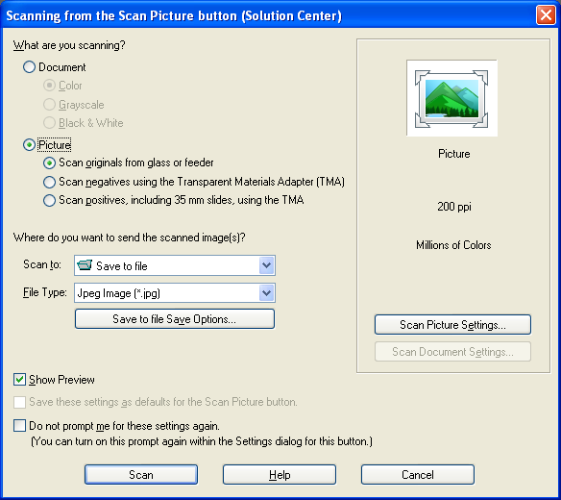
Generally, the best settings on this screen will be:  Resolution(ppi): 300  Output Type: 256 Gray Shades (Grayscale)  scan single picture to file.  Click to continue. |  | 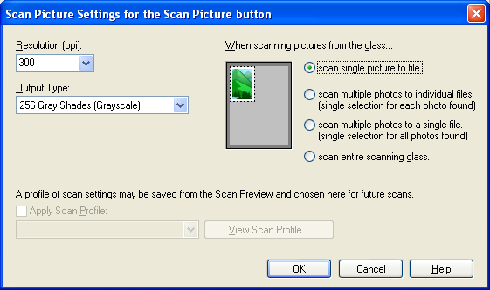
Select Jpeg Image (*.jpg) for the File Type.  Click to continue. |  | 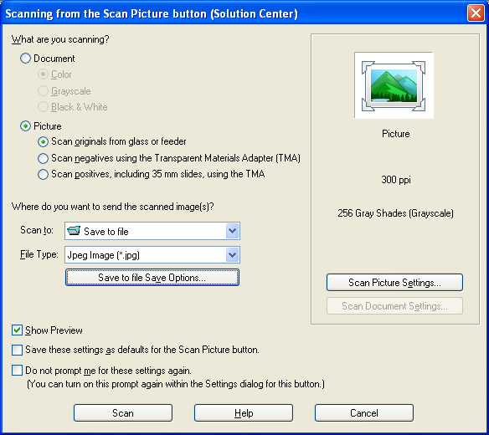
Enter a filename for the scanned document.  Enter a directory where the file is to be stored. (Use the Browse button, and navigate to My Documents\History Project\Photos)  Click to scan the document. (Note: It may take several minutes for the following screen to display if the scanner needs to warm up.) |  | 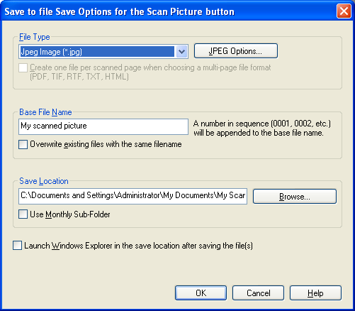
An image of the scanned document will be displayed.  The nodes along the top, sides, and bottom can be dragged to change the portion of the document to be saved to the file.  To save the image to the file click the  button on the lower right of the screen. |  | 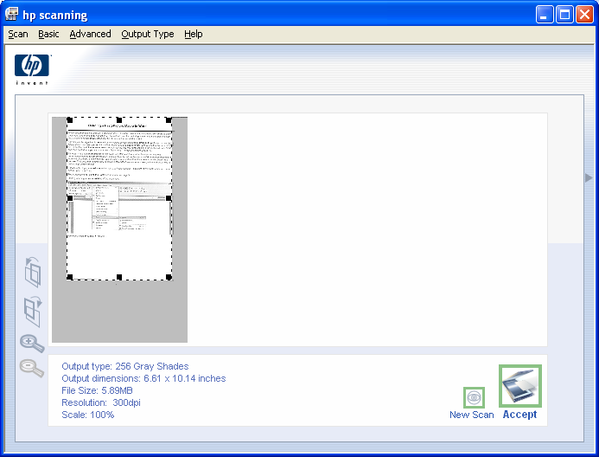
Select No. Scan with current, higher resolution. and then click |  | 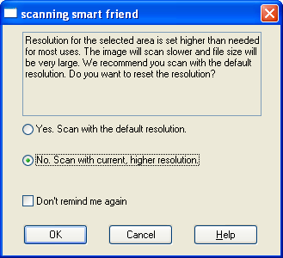
If you would like to include another picture in the same file as the last scanned picture, click Yes. The following screen will appear.  If you click No, the original HP Solution Center screen will appear. From there you can choose to Scan Picture, Scan Document, or close the application. |  | 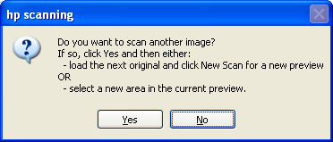
To add a picture to the file, place the new picture in the scanner, and click the  button on the lower right-hand side of the screen. |  | 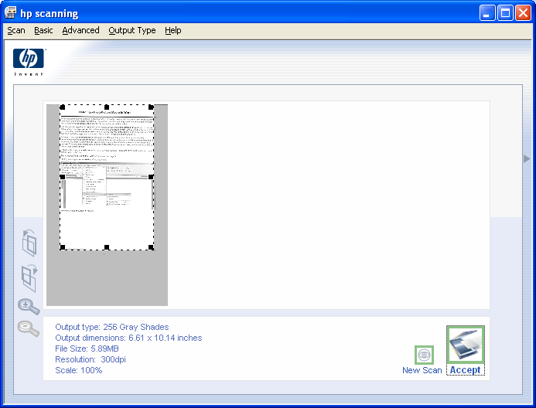
Scanning a Document
Place the document to be scanned on the glass scanning surface.  You may want to experiment with setting the document as Grayscale, or Black & White. For yellowed or discolored originals Grayscale will give better results than Black & White.  Generally documents, other than pictures, should be scanned at 300 ppi, and saved in non-searchable PDF (*.pdf) format.  Place the document to be scanned in the scanner, and then click |  | 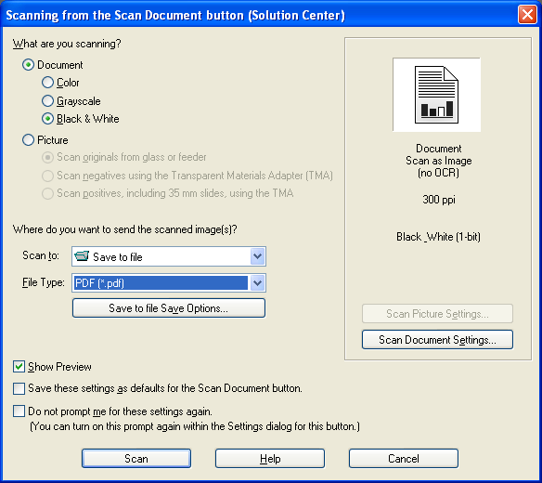
Enter a filename for the scanned document.  Enter a directory where the file is to be stored. (Use the Browse button, and navigate to My Documents\History Project\Documents)  Click to scan the document. (Note: It may take several minutes for the following screen to display if the scanner needs to warm up.) |  | 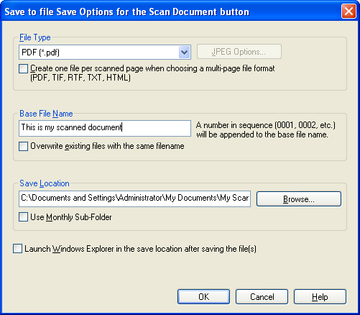
An image of the scanned document will be displayed.  The nodes along the top, sides, and bottom can be dragged to change the portion of the document to be saved to the file.  To save the image to the file click the button on the lower right of the screen. |  | 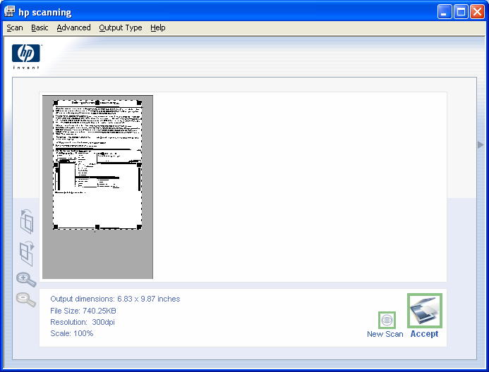
Select No. Scan with current, higher resolution. and then click
If you would like to include another document, such as another page, in the same file as the last scanned document, click Yes. The following screen will appear.

If you click No, the original HP Solution Center screen will appear. From there you can choose to Scan Picture, Scan Document, or close the application.
To add a document to the file, place the new document in the scanner, and click the button on the lower right-hand side of the screen.

Follow the preceding steps for Accepting the scanned image.

